Demonstrate the working of the decision tree based ID3 algorithm. Use an appropriate data set
for building the decision tree and apply this knowledge to classify a new sample.
Dataset 1: Play Tennis
Sky AirTemp Humidity Wind Water Forecast PlayTennis
Sunny Warm Normal Strong Warm Same Yes
Sunny Warm High Strong Warm Same Yes
Rainy Cold High Strong Warm Change No
Sunny Warm High Strong Cool Same Yes
Rainy Warm Normal Weak Warm Same No
Sunny Warm Normal Weak Warm Same Yes
Target Attribute: PlayTennis

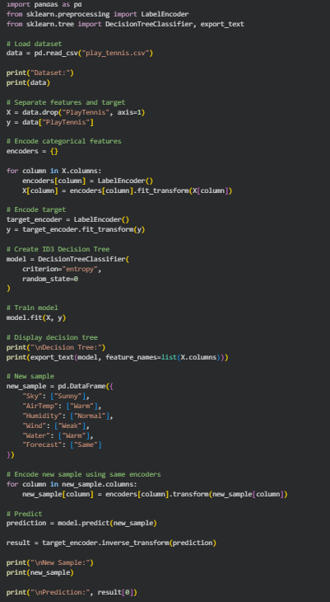
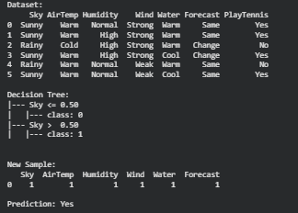

Dataset 2: Loan Approval
Income CreditScore Employment Property Age LoanApproved
High Good Permanent Yes Young Yes
High Good Permanent No Middle Yes
Low Poor Temporary No Young No
Medium Good Permanent Yes Middle Yes
High Average Temporary Yes Old No
High Good Permanent Yes Middle Yes
Target Attribute: LoanApproved

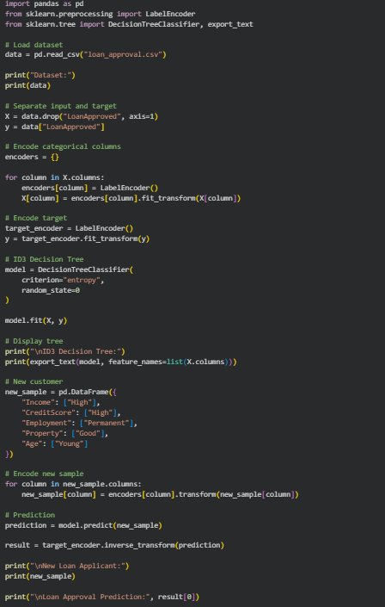
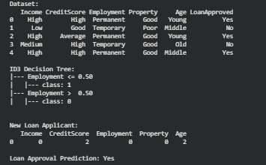

Dataset 3: Student Placement
CGPA Communication Internship Programming Aptitude Placed
High Good Yes Good High Yes
High Excellent Yes Good High Yes
Medium Average No Average Medium No
High Good Yes Excellent High Yes
Low Poor No Average Low No
High Good Yes Good Medium Yes
Target Attribute: Placed

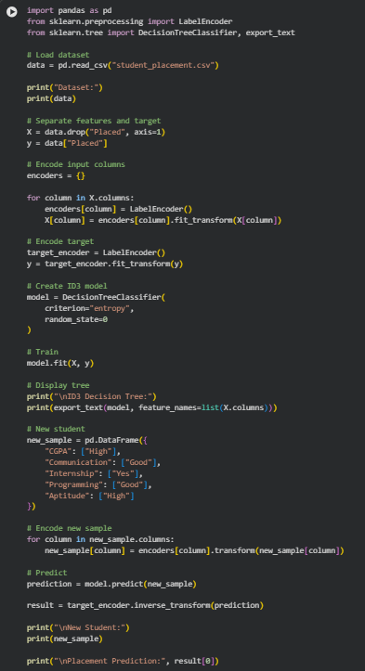

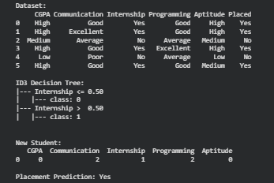

Dataset 4: Disease Diagnosis
Fever Cough Headache BodyPain Fatigue Disease
Yes Yes Yes Yes Yes Positive
Yes Yes No Yes Yes Positive
No Yes Yes No No Negative
Yes Yes Yes No Yes Positive
No No Yes Yes No Negative
Yes Yes No No Yes Positive
Target Attribute: Disease
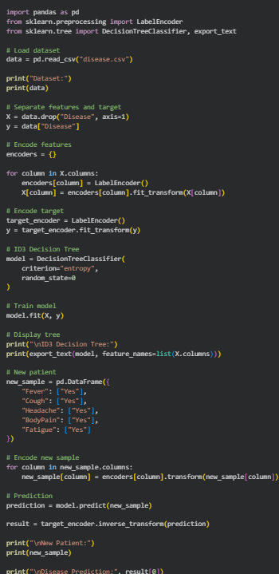
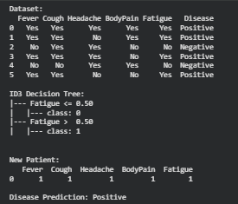

Dataset 5: Email Spam Detection
ContainsLink ContainsOffer UnknownSender Attachment ManyRecipients Spam
Yes Yes Yes No Yes Yes
Yes Yes Yes Yes Yes Yes
No No No No No No
Yes No Yes No Yes Yes
No Yes No Yes No No
Yes Yes Yes No No Yes

